LAB ASSIGNMENT-2

● Procedure:

1. Open Packet Tracer:

■ Launch Cisco Packet Tracer on your computer.

2. Implement a Bus Topology:

■ Drag three computers onto the workspace.

■ Connect them using a single backbone cable (Coaxial Cable).

3. Implement a Star Topology:

■ Drag three computers and a switch onto the workspace.

■ Connect each computer to the switch using straight-through Ethernet

cables.

4. Implement a Ring Topology:

■ Drag three computers onto the workspace.

■ Connect them in a circular manner using crossover cables.

5. Implement a Mesh Topology:

■ Drag three computers onto the workspace.

■ Connect each computer to every other computer using crossover cables.

6. Test Connectivity:

■ For each topology, assign IP addresses to the computers.

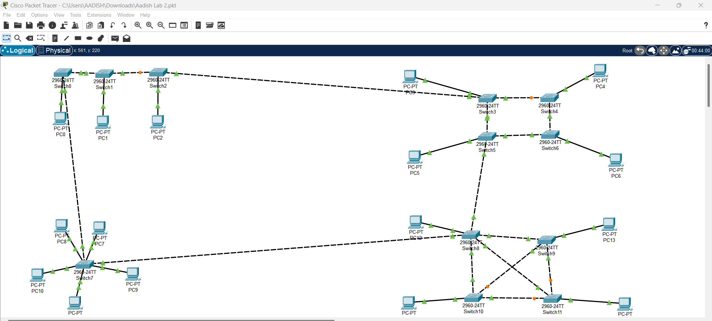■ Use the ping command to test connectivity between all computers.